**Demo Outline**

**Use of Shadow Models for KernelF2**

The demo will focus on one of the use cases, KernelF2 (discussed in Section 2.1); showing demos of all three use cases would result in too little detail for each one.

The next code snippet shows a selection of the KernelF2 base language concepts. We define a couple of values and use various operators and types. Functions, generics and algebraic data types are demonstrated as well.

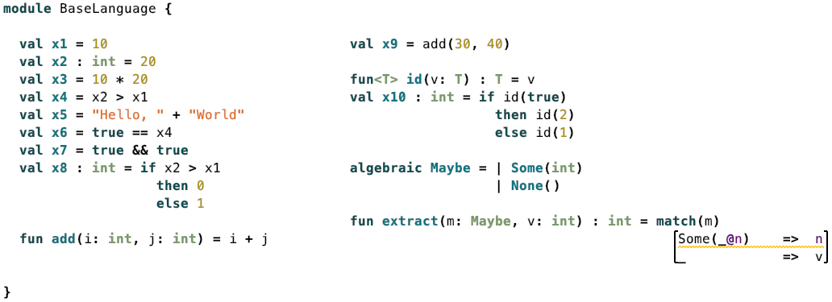

Some of the expressions, such as true && true or 10 * 20 could be evaluated statically; and indeed, there is a Shadow Models transformation for the KernelF2 base language that performs such simplifications:



Now we demonstrate language extension and desugaring. This shows three of the extension constructs defined in the kernelf2.sugar language: enums, alt expressions and decision tables. These are not part of the core, but defined in a modular extension; their semantics is defined through a reduction to the base language. ?maybe? is a Boolean expression that we have added for demo purposes to avoid making up arbitrary Boolean expressions all the time.

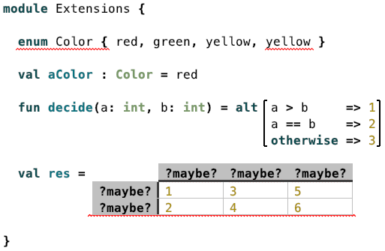

Below is the reduced version of the previous code: enums become constants that follow a particular naming convention, the alt expression becomes nested ifs, and the decision table is translated to nested alt expressions which are then in turn reduced to ifs. Notice how the reduced version contains errors that are produced by type checks of the base language: declarations must have unique names and the <!> expression must never show up. In this case, <!> is produced by the transformation because the decision table has these ?maybe? expressions, so the type system cannot statically figure out whether the table is complete and free from overlaps. **In the demo, I will of course show how changes are propagated incrementally.**

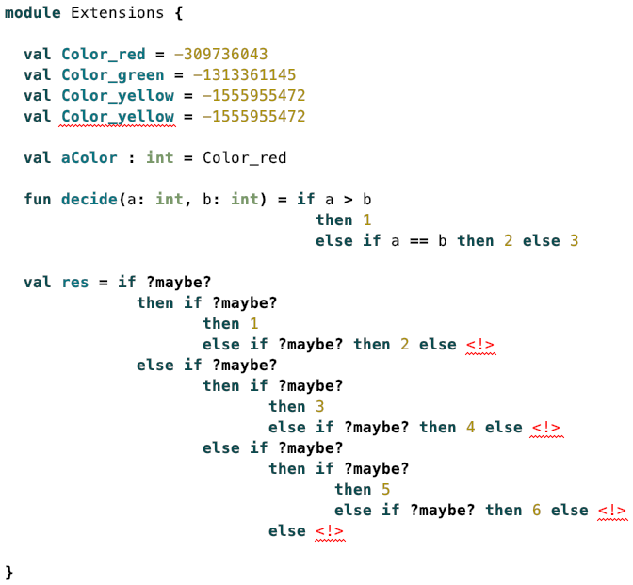

Below we can see an error message in the source model that is lifted from the shadow. No analysis happens on the level of the enum declaration itself. Lifting errors is a core use case for Shadow Models.

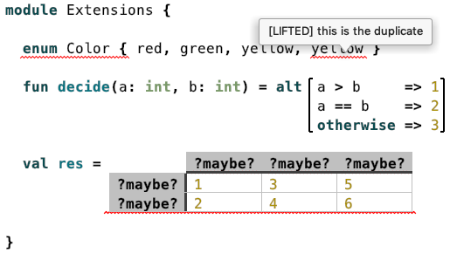

**Implementation - Simplifications**

Here is the entry point to the transformation; it contributes to a predefined transformation that attaches the results of transformations to the shadow repository, a Shadow-Models internal data structure that is also visualized in the IDE. This contribution iterates over all the models in MPS that contain a Module (the root concept of KernelF2, see examples above) and transforms each of them through the fork moduleFork. It copies its input while applying two transformations (declared elsewhere) to a fixpoint.

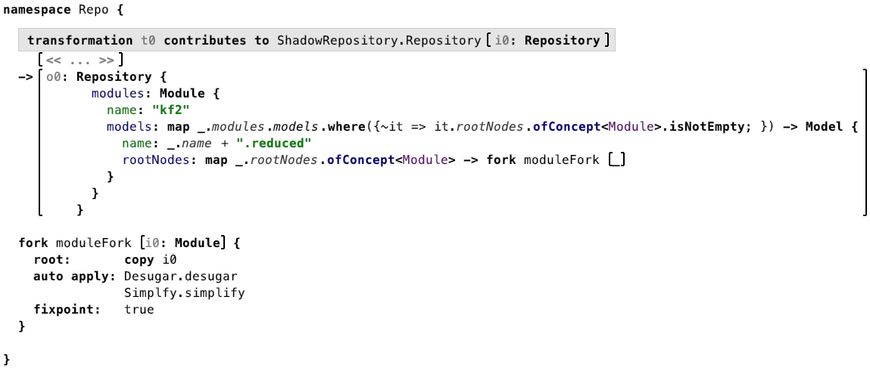

The next screenshot shows the simplify transformation. The first entry declares an abstract transformation from Expr to Expr; the other two polymorphically override the declaration for the LogicalNotExpr and the PlusExpr. The former transforms a !true to false and the second one performs the static addition of number literals.

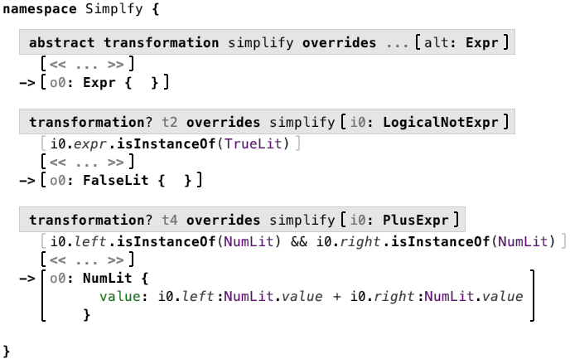

The concrete simplify transformations are defined in the same language as its abstract declaration; this is not the case for the desugar transformation. Only the abstract declaration is specified in the kernelf.core language, with language extensions expected to provide the overrides:

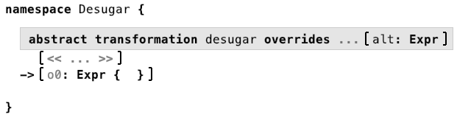

**Implementation - Enums**

Let’s take a look at the reduction of enums to constants. The respective transformation overrides the desugar transformation for EnumDecls. The transformation iterates over the literals in the enum, and trsansforms each of them into a Constant (note how the rule is allowed to create multiple outputs as opposed to just one, as defined in the abstract declaration). The name and the value properties of the created Constant are computed with Java expressions that access the properties of the input node. The mapping between the each EnumLiteral and the resulting Constant is stored in the enumLit-ToConst mapping label.

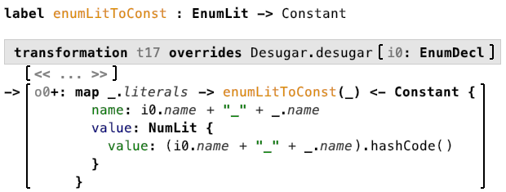

We need two more transformations. First, we have to transform every EnumType (as in val x: Color = …) into an IntType (val x: int = …), because all enums are transformed to int constants. And whenever we reference an enum literal using a EnumLitRef expression, we have to transform it to a reference to the particular Constant that has been created from the referenced literal; we can find it by querying the previously populated label.

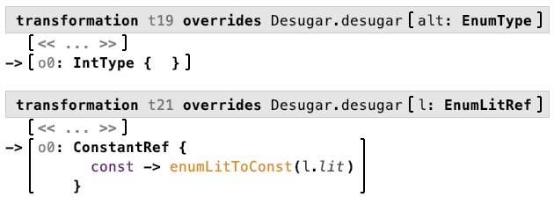

**Implementation – Error Lifting for Enums**

Error Lifing relies on detecting particular error messages on output nodes of the transformation and, if one exists, back-propagating a new error to one or more of the input nodes. To this end, transformation authors override a predefined operation liftMessage “inside” the creator of the target node. Here is the example for the enums:

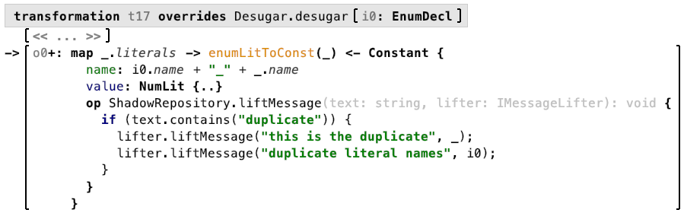

The operation implementation, written inside the Constant, checks if the error message(s) reported by MPS on this Constant contain the word *“duplicate”*. If so, we propagate a message *“this is the duplicate”* to the currently transformed literal, and another error *“duplicate literal names”* to the input EnumDecl. The framework takes care automatically of removing the lifted errors if their causes go away.

**Implementation – Alt Expressions**

We conclude the demo with the transformation of the AltExpression. What makes this interesting is that a flat list of alternatives must be transformed to a tree of nested IfExpressions. Transforming lists to trees is achieved conveniently with the fold function in functional programming, which is why we have added a corresponding transformation primitive to the Shadow Model transformation language.

A foldR function joins output for the *n*-th element of the list to what has been constructed for the *n-1*-th list element. In this case, we create a new if that reuses the condition of the current option and puts its value into the then part. The else part of the currently constructed if is whatever the previous iteration has created, represented by the acc (short for accumulator) expression inside the foldR. For the first entry in the alt’s list of options, we pass a seed value to foldR; in our case it is the NeverLit, rendered as <!>.

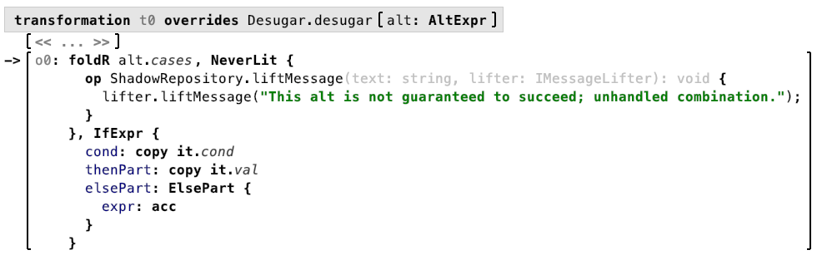

This transformation will create a set of nested ifs, where the last one always has an <!> in its else part. However, if we look above, the transformation of the alt-expression in the Extensions module did not include an else <!> at the tail. Why is this? The reason is the otherwise in the last option, it’s basically a catch-all clause. That last option will be transformed to by the transformation above:

**if** **true** **then** 3 **else** <!>

However, the set of base language simplifications defines one that transforms an if true to the then part, because we know statically the else option will never occur:

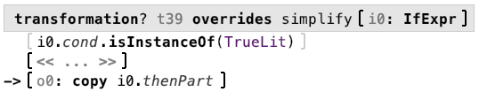

The case above thus simply becomes 3 and the else <!> goes away. As a corollary, this means that whenever a <!> is created as the result of the transformation of an alt expression (and survives simplification), then this is an indication of an error in the alt expression; which is why we add a corresponding lifter to the transformation, as can be seen above.

**IDE Integrations**

The Shadow Repository in the MPS project view that shows the results of all transformations; double clicking any root opens it in an editor, and the incremental transformations can be observed in realtime.



The Fork Explorer shows the execution of the transformations, including the inputs it processes and the output nodes it creates.

